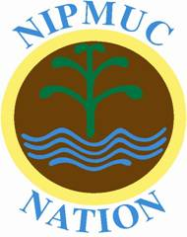
25 Main St
South Grafton, MA 01560

July 7, 2020

To All Interested Parties:

The Nipmuc Nation stands in opposition to all sport team mascots/nicknames/logos that falsely impersonate the lives of Indigenous People. We support legislation that will remove and prohibit those mascots/nicknames/logos and prohibit them in the Massachusetts school system. We also encourage the school systems of Massachusetts, both public and private, to create and integrate into their regular curriculums educational units dedicated to indigenous culture and the long-lasting effects of colonization.

These mascots/nicknames/logos are derogatory and harmful to our people. They perpetrate negative stereotypes associated with Indigenous people. And, despite the claims of their supporters, these mascots/nicknames/logos do NOT honor us in any way.

As humans living among the many communities in the Commonwealth, we would prefer to speak and reason with townspeople about the harmful effects of their school mascots. Unfortunately, our voices are not heard and many, many schools and individuals still cling to these images claiming that their lives will be disrupted by removing them.

Therefore, we support state-wide initiatives and laws to remove and prohibit indigenous mascots/nicknames/logos from all schools and sport teams in the Commonwealth and beyond.

Respectfully,
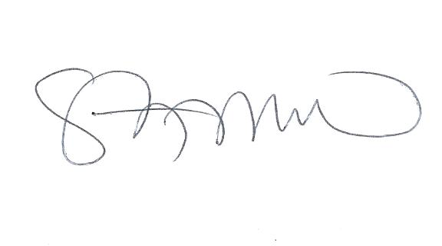
Cheryll Toney Holley
Sonksq
Nipmuc Nation

